**Difference between Nodelist and HTML Collection**

**And also**

**Difference between document.getElementsByClasssName or TagName ( ) and document.querySelectorAll ( )**

Both HTML Collection and Nodelist are not arrays, both of them are numbered objects

A Nodelist can contains every nodes of every node type, i.e ELEMENT_NODE , TEXT_NODE and others also

A HTML Collection can only contain ELEMENT_NODE type of Nodes, meaning it only contain HTML Elements

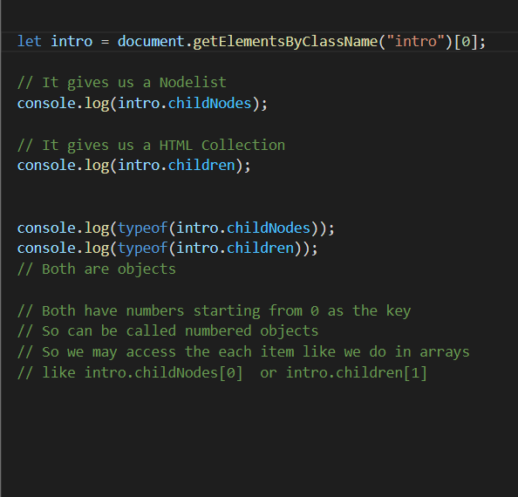

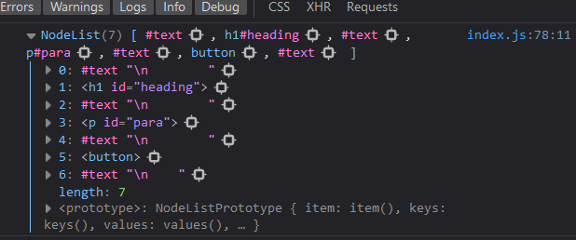

See Nodelist is containing nodes of every type

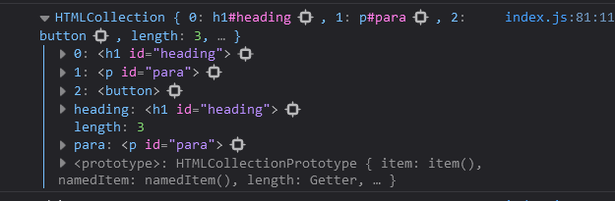

See HTML Collection is containing only Elements

**Most Important Difference Between them**

A Nodelist is static, where as A HTML Collection is live. Meaning if we add an element from javascript than Nodelist won’t notice so it won’t update either. whereas HTML Collection will instantly notice and will update our HTML Collection

But that being said

* Nodelist returned by .classNode is live
* but Nodelist returned by document.querySelector is static

See

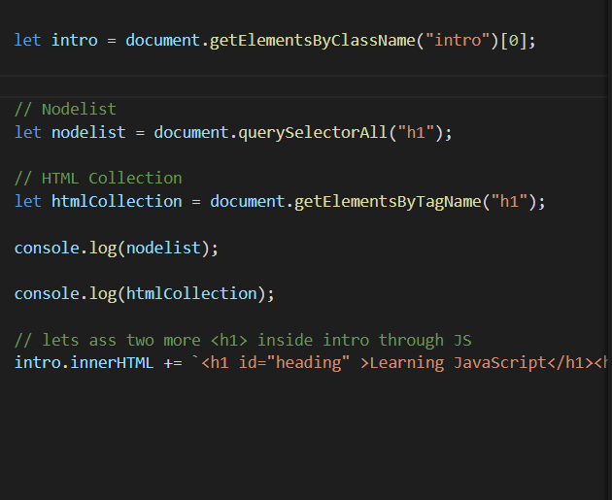

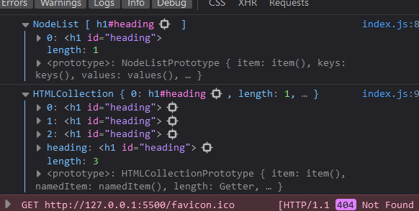

As you can see, after adding more <h1> through javascript into the DOM tree or HTML Collection has updated where Nodelist isn’t updated

But the NOdelist returned by .childNodes is found to be non static

See

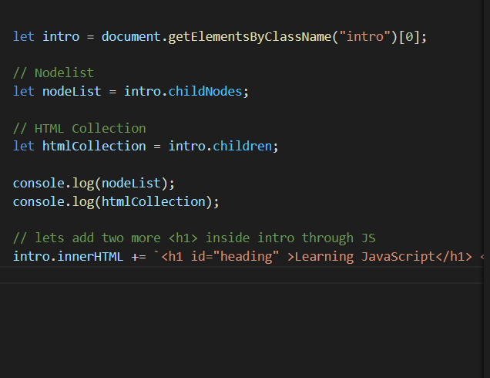

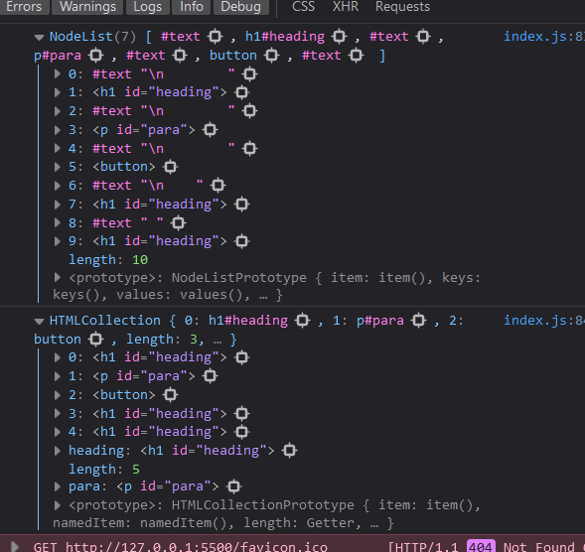

See after we added more <h1> tag from javascript into the DOM tree both Nodelist and HTML Collection got updated